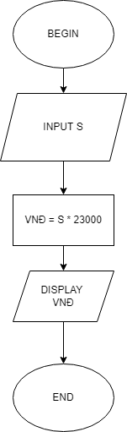BEGIN

INPUT S

VNĐ = S \* 23000

DISPLAY VNĐ

END